**Climate Change**

Climate change is the seasonal changes over a long period with respect to the growing accumulation of greenhouse gases in the atmosphere.

The accumulation of greenhouse gases as a result of climate change may lead to global warming.

**Global Warming**

**Global warming** is a long-term rise in the average temperature of the earth's climate system.

**Some Harmful Human Activities That Contribute to The Emission of Greenhouse Gases into The Atmosphere**

Some of the harmful human activities emit greenhouse gases and these include bush fire, burning of rubbish, and smoke from burnt petroleum product in cars.

**1. Bush fire**

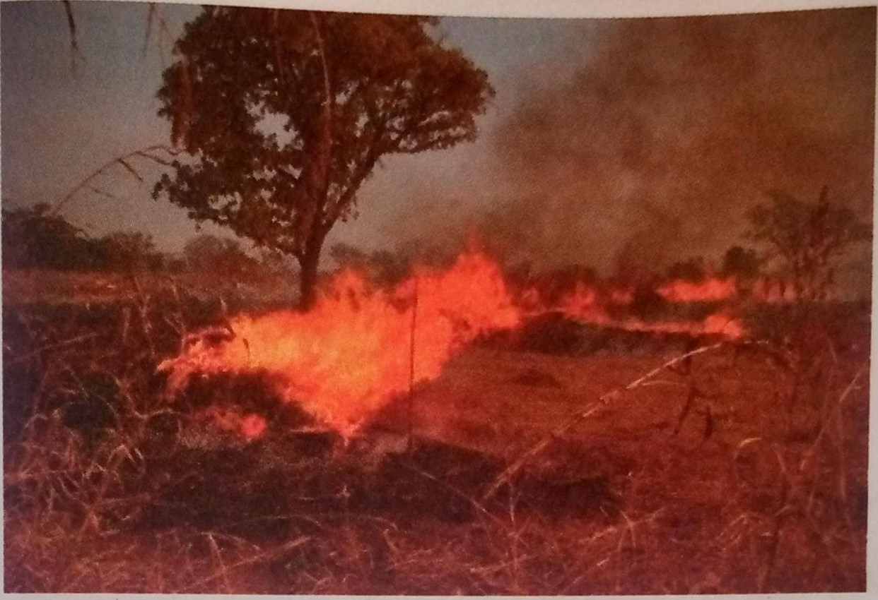During the dry season some hunting activities results in the intentional burning of bush. Smoking also can start bush fires in dry places. Bush fires destroy grassland and forest and, in the process, plenty smoke carrying harmful gases rise to the sky.

2. Burning of rubbish

In our communities there is improper disposal of wastes. Most of the rubbish or waste are burnt.

The smoke from the burning of rubbish pollutes the air. The smoke and bad odour make breathing difficult.

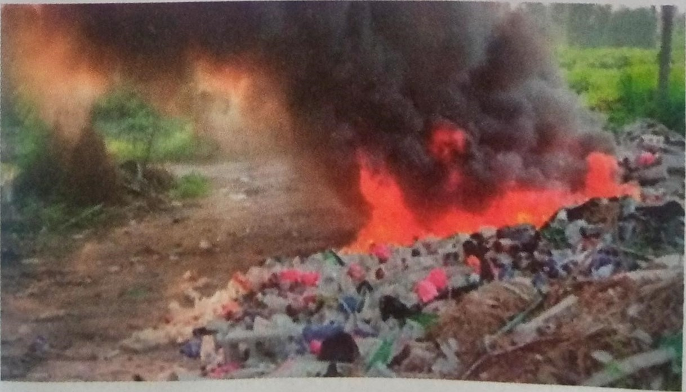It makes people to fall sick.

1. Exhaust fumes from cars

A lot of poisonous gas are emitted from cars because of the burning of petrol and diesel. These gases rise up into the sky.



**Effect of smoke from bush fires, burning of rubbish and exhaust from cars on the environment**

The gases emitted from burning bushes, burning rubbish and burning petrol in cars rise to the sky. These gases form a blanket so that heat from the earth cannot escape but are rather trapped. This is called Greenhouse effect. The trapped heat causes the atmosphere to become warm. This is called global warming.

This warming of the atmosphere causes severe rainfall and flooding in some parts of the world.

1. It also causes drought or lack of rain in some places.
2. Both flood and drought affect farming in such places.

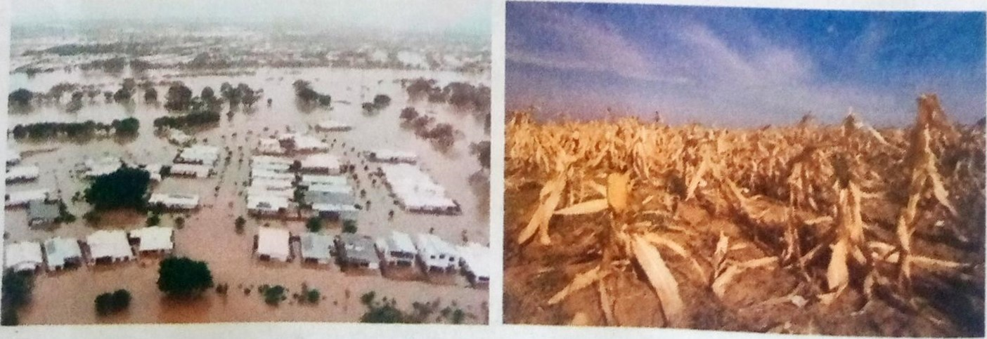  Flooded Area Drought- Stricken Area

1. The heating of the atmosphere also causes ice at the poles of the earth to be melting gradually. This increases the level of sea water and the destruction of coastlands. Fishing is therefore affected.

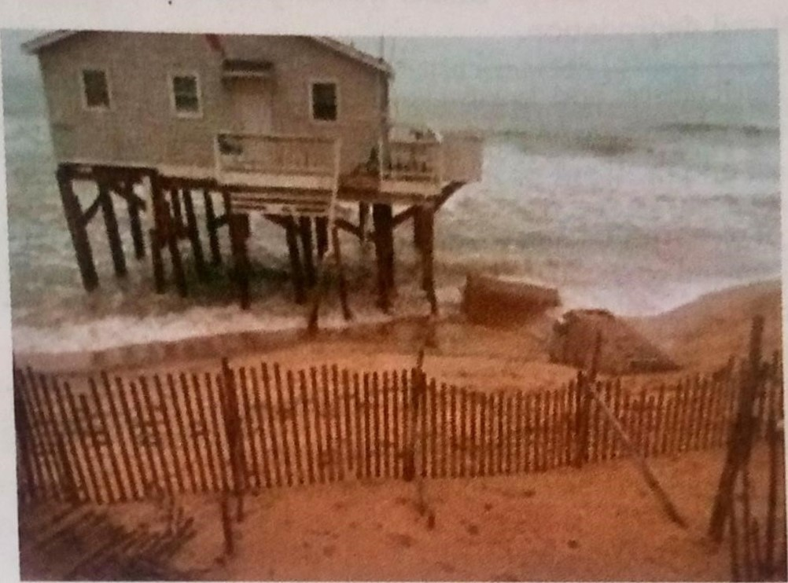

Destroyed Coastland

**Human activities that produce greenhouse gases**

1. Burning of fossil fuels
2. Industrial emission of carbon dioxide
3. Deforestation
4. Industry creates chlorofluorocarbons (CFCs) and other halocarbons for use in various products and industrial processes
5. Fertilizer use increases nitrous oxide emissions.
6. Domesticated animals emit methane

**Consequences of the Greenhouse Effect**

1. Flooding of islands and coastal cities. Global warming caused by greenhouse effect will lead to a rise in sea level causing flooding in the coastal areas.
2. Hurricanes will be more devastating. The intensification of the greenhouse effect does not cause these extreme climatic events, but it does increase the intensity. Hurricanes are connected with sea temperature. They only form over waters that have a temperature of at least 26.51 0C.
3. Migration of species. Many animal species will be forced to migrate in order to survive the changes in the main climatic patterns altered by the progressive increase in temperatures.
4. Desertification of fertile areas. Global warming has a profound impact on the processes of soil degradation.
5. Impact on agriculture and livestock. Global warming has already altered the length of the growing season in large parts of the planet. This leads to a reduction in agricultural and livestock production.
6. The spread of diseases. Global warming causes infectious diseases such as malaria, cholera and spread to many more areas of the planet. On the other hand, extreme heat will increase cardiovascular and respiratory problems.

**How to Solve the Consequences of the Greenhouse Effect**

1. Use renewable energy.
2. Use public transport and other non-polluting means, such as electric vehicles or bicycles.
3. Promote ecological awareness among citizens and different administrations.
4. Commit to recycling and the circular economy.
5. Reduce the consumption of meat.
6. Consume organic products

**Ways By Which Human Beings Can Adapt to Climate Change**

1. **Construction of Waterworld homes**: Some countries in the world has begun working on floatation homes. This is due to the excessive flooding that occur due to climate change.
2. **Underground cities**: Some cities in the world especially Hong Kong has moved many power stations and reservoirs under the earth just to create space for people. Cities built underground avoid the bad effects of global warming.
3. **Smart energy**: A warming planet means many homes and businesses will use more energy and spend more on electricity bills to keep cool. Solar panels have now been created to reduce expenditure and meet demand of electricity.
4. **Vertical farms**: These are indoor farming. The emergence of pest that destroy crops in alarming rate as well as drought have made indoor farming effective and more profitable.
5. **Climate-adapted crops**: The introduction of drought resistant crops has help to cultivate crops even in the dry season.