**EQUIVALENT FRACTIONS**

Equivalent fractions can be defined as **fractions that may have different numerators and denominators but they represent the same value**. For example, $\frac{9}{12}$ and $\frac{6}{8}$ are equivalent fractions because both are equal to $\frac{3}{4}$.

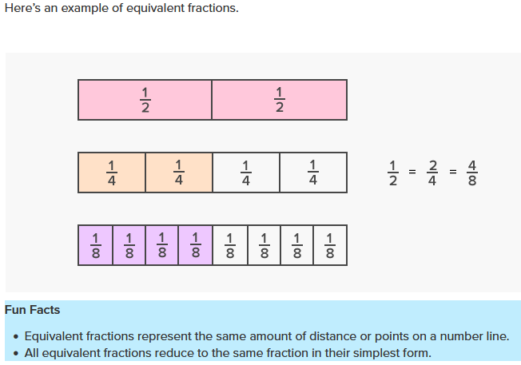

**How To Find Equivalent Fractions?**

Equivalent fractions can be written by multiplying or dividing both the numerator and the denominator by the same number. This is the reason why these fractions get reduced to the same number when they are simplified. Let us understand the two ways in which we can make equivalent fractions:

1. Multiply the numerator and the denominator by the same number.
2. Divide the numerator and the denominator by the same number.

**1. Multiply the Numerator and Denominator by the Same Number**

To find the equivalent fractions for any given fraction, multiply the numerator and the denominator by the same number. For example, to find an equivalent fraction of 3/4, multiply the numerator 3 and the denominator 4 by the same number, say, 2. Thus, 6/8 is an equivalent fraction of 3/4. We can find some other equivalent fractions by multiplying the numerator and the denominator of the given fraction by same number.

**EXAMPLES**

$\frac{3×3}{4×3}=\frac{9}{12}$

$\frac{3×4}{4×4}=\frac{12}{16}$

$\frac{3×5}{4×5}=\frac{15}{20}$

Thus, the equivalent fractions of $\frac{3}{4}$  are $\frac{9}{12}$, $\frac{12}{16}$, and $\frac{15}{20}$

**2. Divide the Numerator and Denominator by the Same Number**

To find the equivalent fractions for any given fraction, divide the numerator and the denominator by the same number. For example, to find an equivalent fraction of $\frac{72}{108}$, we will first find their common factors. We know that 2 is a common factor of both 72 and 108. Hence, an equivalent fraction of $\frac{72}{108}$ can be found by dividing its numerator and denominator by 2.

$\frac{72÷2}{108÷2}=\frac{36}{54}$

Thus, $\frac{36}{54 }$ is an equivalent fraction of $\frac{72}{108}$. Let us see how the fraction is further simplified.

1. 2 is a common factor of 36 and 54. Thus, $\frac{36÷2}{54÷2}=\frac{18}{27}$
2. Again, 3 is a common factor of 18 and 27. Thus, $\frac{18÷3}{27÷3}=\frac{6}{9}$
3. Again, 3 is a common factor of 6 and 9. Thus, $\frac{6÷3}{9÷3}=\frac{2}{3}$

Therefore, the equivalent fractions of $\frac{72}{108}$ are $\frac{36}{54}$, $\frac{18}{27}$., $\frac{6}{9}$., and $\frac{2}{3}$. Here, $\frac{2}{3}$ is the simplified form of $\frac{72}{108}$ as there is no common factor (other than 1) of 2 and 3.

**How To Determine if Two Fractions are Equivalent?**

We need to simplify the given fractions to find whether they are equivalent or not. Simplification to get equivalent numbers can be done to a point where both the numerator and denominator should still be whole numbers. There are various methods to identify if the given fractions are equivalent. Some of them are:

1. Making the denominators the same
2. Finding the decimal form of both the fractions
3. Cross multiplication method
4. Visual method

Let us identify whether $\frac{2}{6}$ and $\frac{3}{9}$ are equivalent fractions by each of these methods.

**1. Making the Denominators the Same**

The denominators of the fractions, $\frac{2}{6}$ and $\frac{3}{9}$ are 6 and 9. The LCM of the denominators 6 and 9 is 18. Let us make the denominators of both fractions 18, by multiplying them with suitable numbers.

$\frac{2×3}{6×3}=\frac{6}{18}$

$\frac{3×2}{9×2}=\frac{6}{18}$

We can observe that both the fractions are equivalent to the same fraction $\frac{6}{18}$. Thus, the given fractions are equivalent.

**Note:**If the fractions are NOT equivalent, we can check the greater or smaller fraction by looking at the numerator of both the resultant fractions. Hence, this method can also be used for comparing fractions.

**2. Cross Multiplication Method**

To identify whether $\frac{2}{6}$ and $\frac{3}{9}$ are equivalent, we cross multiply them. If both the products are the same, the fractions are equivalent.

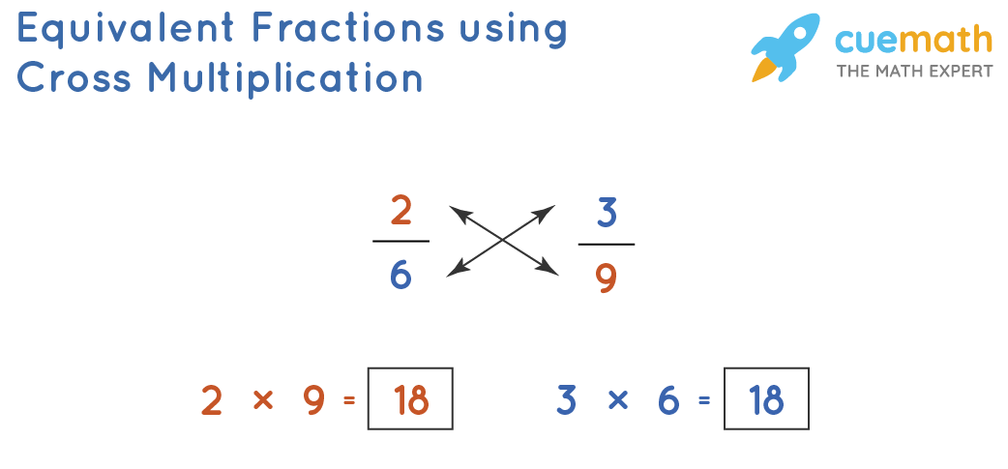

Since both the products here are 18, the given fractions are equivalent.